There are (at least) 3 general categories of costs to consider:

- Engineering costs associated with new upgrades and development of user features

In principle, engineering costs are fixed costs and have a limited relationship to the number of users. For example, selling the next unit of a video game is not associated with any increase in software engineering.

On the other hand, for more complex software products, a growing customer base makes new demands on software including bug fixing, addition of new models/features etc.

B. Support

Support over e-mail or the phone has a non-trivial marginal cost associated with it. To some extent this marginal cost can be diffused through creating a knowledge-base forum (Social CRM) where users post a question and super-user answers it.

According to some research however, even in the best circumstances, customer service can only be reduced to ⅓ of a pure ticketing and knowledge based system.

C. Server-side costs of processing, storage and bandwidth

Looking at published cost-of-service numbers for public SaaS companies, the number ranges from the teens as a percentage of revenue to 30-40% or higher.

Here is a potential template:

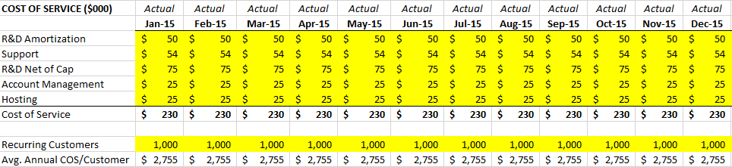

- R&D Amortization – the economic cost of your current release(s)
- Technical Support – typically, your call center handling inbound customer questions
- R&D Net of Cap – I look at the expenses in my development cost center and exclude software capitalization. What remains, in my mind, is the cost of software maintenance and supporting current releases. Not new development.
- Account Management – the sales team responsible for taking care of current customers.
- Hosting – your hosting and data center costs.

Typically, a good SaaS business model should have a gross margin of about 80-90%. This means that the Cost of Goods Sold should be around 10-20% of the total Revenue. The product that the SaaS companies provide is a software enabled service, mainly delivered over the Internet. Therefore, the items that comprise the COGS for this business model are different from those found in the COGS of traditional Software businesses.
Charging: $60K/year per license
This is a list of the general costs that comprise the COGS for a SaaS business and are not part of the Operating Expenses:
- Application hosting and monitoring costs:
- Customer support and account management costs
- Data communication expense
- Software license fees for products embedded in the application
- Website development and support costs
- Professional services and training personnel costs
- Costs of subscriptions
https://www.opexengine.com/your-second-highest-cost-in-running-a-saas-company/

Expenses
Turning to expenses, one of the most important factors from a P&L perspective is the appropriate classification of expenses. The two main categories of expenses are Costs of Goods Sold (or COGS) and Operating Expenses. Both represent different types of expenses, and are important metrics from managerial and investor points of views.

Cost of Goods Sold
While the concept of Cost of Goods Sold is fairly simple, it is an important one. It is defined as the direct costs attributable to the production and delivery of the goods or services sold by a company. As we are dealing with a SaaS company, this will generally include the following costs: hosting, cloud and database fees; support personnel and customer care costs; third-party web fees (ex. Content delivery networks, embedded software); and customer on-boarding costs.

Operating Expenses
On the other side of the calculation, the Operating Expenses are those costs incurred by a company through its normal business operations. In other words, costs which are not directly attributable to the sale or delivery of a product or service. This would generally include salaries, rent, advertising, legal & professional fees, etc.
Example: Now that we have our COGS and Operating Expenses defined, let’s put together our projected expenses for the year.

